For submission to *Biology Letters*

**Title: (to be determined…)**

Syuan-Jyun Sun1,2,*, Wei-Jiun Lin3, Gen-Chang Hsu4, Ming-Yang Megan Chang3

1Department of Ecology & Evolutionary Biology, University of Michigan, Ann Arbor, MI 48109, USA

2International Degree Program in Climate Change and Sustainable Development, National Taiwan University, Taipei 10617, Taiwan

3Institute of Ecology and Evolutionary Biology, National Taiwan University, Taipei, Taiwan

4Department of Life Science, National Taiwan University, Taipei, Taiwan

*Corresponding authors:

sysun@umich.edu

**Abstract:**

**Introduction:**

The academic job market has been increasingly competitive in many fields of science, technology, engineering, and mathematics (STEM)[1–3], with more PhDs produced but vacancies opening for tenure-track academic positions remaining constant in the past four decades [4,5]. In the US, for example, beginning in the life sciences, with 7.6% new PhDs found tenure-track positions within three years after graduation in 2010, this surplus has widely expanded to other STEM fields [6].

The increasing intensity of competition for tenure-track positions, due to disproportionally high number of accumulating applicants per tenure-track position [5], has resulted in higher expectation for academic performance shaped by a ‘publish or perish’ culture [7]. A survey of evolutionary biologists recruited as junior researchers at the CNRS (National Centre for Scientific Research) in France showed that nearly twice as many as papers had been published from academics recruited in 2013 compared to those in 2005 [8]. Although the minimum of educational requirement for a tenure-track position is having a PhD degree, it has become increasingly frequent for applicants to have one or even more postdoctoral appointments. Consequently, many STEM PhDs work as postdoctoral researchers for a prolonged period and wait for future opportunities until they are competitive enough in the academic job market [9], whereas some turn to alternative careers outside academia. From the CNRS example, Brischoux and Angelier (2015) also showed that the time elapsed between first paper publication and recruitment had increased from 3.25 to 8 years. The increase in postdoctoral training time can be detrimental not only to the scientific community but also to individuals because this increases the age at which researchers become independent, during which the postdocs have to trade-off families for research, with fixed-term and relatively low-paying jobs [10].

Despite widely claimed that publication expectation and career duration have surged, empirical quantification and the determinants of the evolution of academic profiles over time remains understudied. In addition to research productivity, which directly predicts success and time to recruitment [11], prestige and origin of doctoral-granting institutions have become a critical indicator for academic employment [11], especially in East Asian countries [12]. With their initiative to build world-class universities, many East Asian universities preferentially recruit returnees who obtain PhD degrees from top-ranking universities in Western countries. Hence, competition for limited tenure-track positions is exacerbated when foreign PhDs are favored, leaving domestically-trained PhDs substantially deprived of career development opportunities[13]. Yet, whether and to what extent publication expectation and career duration differ between foreign and domestic PhDs, and if their academic productivity varies between pre- and post-employment, remain largely unexplored.

In this study, we examine how academic performance as well as the duration required to secure a faculty position and promotion to full professor changed over time, and their links to PhD prestige, PhD origin, and gender. Specifically, we test the following questions: (1) Have publication expectations and time to getting a faculty position or promotion risen over time? (2) Is the time to getting a faculty position and promotion determined by PhD prestige and origin, academic performance, and gender? (3) Do new PI and promoted full professors vary in academic performance before and after getting a job and promotion? To address these questions, we study the trend between 1987 and 2021 on 140 faculty members in the field of biological sciences in Taiwan. With this study we aim to provide empirical evidence to illustrate temporal variations in how much researchers have to publish to secure a faculty position and promotion, the role of PhD prestige and origin as well as gender in determining the success of academic employment, and how these factors contribute to their future academic performance.

**Materials and Methods:**

1. Survey materials

In total, we surveyed 702 tenure-track faculty at seven universities and one research institute. Of all universities in Taiwan, these seven were qualified as research-intensive universities and were ranked top 150 according to five key metrics based on 2022 QS Asia University Rankings (<https://www.topuniversities.com/>). Wealso included academics from Academia Sinica, a leading academic institution in Taiwan. Together, these eight institutes encompass 34 academic departments/divisions that serve as tenure homes to the field of biological and environmental sciences (e.g., ecology, evolution, biodiversity, zoology, and botany; see Appendix A for details). We excluded researchers in biomedical sciences because publication rates, performance, and collaboration opportunities can vary considerably these fields.

The survey, conducted between November and December, 2021, identified 140 who had an updated curriculum vitae (CV) online (e.g., institutional or personal websites, Open Researcher and Contributor ID (ORCID)), with key information on the year of PhD completion, the year of appointment as a new PI, the year of promotion to full professor, and data on gender, which is well-documented as a key determinant of performance. We also determined the ranking of the universities from which each PI obtained their PhD degree, and if the degree was obtained from a university based in Taiwan. The ranking (based on 2022 QS World University Rankings) ranged from 3 for University of Cambridge and Stanford University to universities around 1200.

1. Measurement of academic performance

We collected data on academic performance, measured as h-index, from the Publish or Perish software using Google Scholar data, which is freely available and more transparent for tenure reviews. We included citable publications, including peer-reviewed papers, book chapters, regardless of whether the authors are the first or corresponding authors, while PhD theses and conference presentations were excluded. We noted that there were other matrices, such as the number of published papers or citations, also commonly used for measuring academic performance. However, we found that in our study h-index was highly and linearly correlated with the number of published papers (Pearson’s correlation coefficient: *r*(350) = 0.906, *p* < 0.001), as had been found elsewhere. We thus focused on using h-index, which incorporates the assessment of quantity (number of papers) and quality (citations) of publication, and is becoming generally accepted measure of academic success.

h-indexes were calculated within the five-year interval both before and after the year when appointed as a new PI, and when promoted to full professor, generating up to four h-indexes for each individual. The duration of five years was determined in our study because it is commonly used to evaluate the most recent academic performance both for hiring a new PI and for promotion to full professor. The year of appointment as a new PI and promotion to full professor was considered as of the performance before getting a job or promotion, respectively. For example, a new PI who started the position in 2010 would have an h-index measured for publications between 2006 and 2010 (i.e., before), and another h-index measured for publications between 2011 and 2015 (i.e., after). The rationale here is that publications appearing in the year of new appointment and promotion most likely contributed to evaluation of academic performance prior to successful application and promotion as published papers or manuscripts ‘accepted’ or ‘in press’. We did not consider ‘after’ h-indexes for PIs who had got a job or had been promoted to full professors less than five years so that all performances had the same duration to compare with.

1. Statistical analysis

*Analysis of academic performance.* To evaluate if expectations of academic performance have risen over time, we analyzed the h-indexes prior to starting as a new PI, with PhD university location (i.e., whether the PhD degree was obtained from a Taiwanese university), PhD university ranking, gender, and their interaction with the year when started as a new PI as explanatory factors/covariates. Likewise, the academic performance prior to promotion to full professor was analyzed in a similar manner, with the year started as a new PI replaced by the year promoted to full professor. In all models, we included the Department nested within the University as a random effect.

*Analysis of the duration required for becoming a PI or promotion.* We analyzed the duration required for becoming a new PI after obtaining a PhD by including PhD university location, PhD university ranking, gender, academic performance, and their interactions with the year started as a new PI as explanatory factors/covariates. The duration required for promotion to full professor was analyzed in a similar model but the year of promotion was used instead. We included the Department nested within the University as a random effect.

*Analysis of change in academic performance.* To compare performance before and after becoming a new PI, we analyzed h-indexes in a five-year duration before and after becoming a new PI. We included PhD university location, PhD university ranking, gender, the timing when h-indexes were measured (i.e., before vs. after) as explanatory factors/covariates, and their interactions with the year started as a new PI. In addition to the Department nested within the University, we included the individual ID as a second random effect since each PI could be repeatedly sampled both before and after becoming a new PI.

All analyses were performed in the R statistical environment (version 4.1.2) [14]. Generalized linear mixed-effects models (GLMMs) were performed in the package ’lme4’ [15] using Gaussian distributions. Post-hoc pairwise comparisons were performed in the package ‘emmeans’[16]. Response variables, including h-index and duration required for becoming a PI or promotion, were log-transformed prior to analyses to ensure that the model residuals meet the requirements of normal distribution for regression. Since PhD university ranking, the year when started as a new PI, and the year of promotion to full professor were different in scale compared to the response variables, they were standardized prior to analyses. We began our analyses with models incorporating possible interactions, and then dropped non-significant (*p* > 0.05 as reported by ANOVA) interactions involving the fixed effects, reaching the minimal adequate models as reported in the results.

**Results:**

In total, we collected data for 140 tenure-track faculty, of which nearly half (43.6%) were full professors, whereas 25.0% were associate professors, and 31.4% were assistant professors. The gender difference was substantial, with males (109) four times as prevalent as females (31). The universities from which the PI obtained their PhD degree varied widely in the ranking of prestige among 73 universities from 16 countries (Fig. S1 and S2). Nearly half of the PIs had obtained their PhDs from USA (47%), followed by Taiwan (31%), and then relatively few from UK (5%) and other countries.

We found that faculty who were offered tenure-track positions more recently had had higher academic performance (i.e., h-index) prior to becoming a PI (*χ²* = 74.68, d.f. = 1, *p* < 0.001; Fig. 1a), whereas PIs performed equally well to be promoted to full professors irrespective of time (*χ²* = 0.97, d.f. = 1, *p* = 0.324; Fig. 1b). Although males had on average higher performance than females when becoming a new PI, no such gender difference was found when promoted to full professor. Whether or not a PI had obtained a PhD degree from Taiwan and the PhD university ranking had no effect on the performance required, either for getting a job or promoting to full professor (Table 1).

Next, we investigated whether academic performance and PhD university prestige predicted the duration required to get a faculty position, and if the pattern differed between faculty attained a PhD degree inside and outside Taiwan. We found that PIs spent more time post PhD before obtaining a tenure-track position in recent years, but higher academic performance reduced this duration (Year x performance: *χ²* = 6.06, d.f. = 1, *p* = 0.014; Fig. 1c). In contrast, we found that PIs spent more time for promotion to full professors when started as PIs more recently (*χ²* = 7.03, d.f. = 1, *p* = 0.008; Fig. 1d), which was not affected by their academic performance. Neither the duration to get a job nor duration required for promotion was affected by whether or not PhDs were obtained from Taiwan, PhD university prestige, and gender.

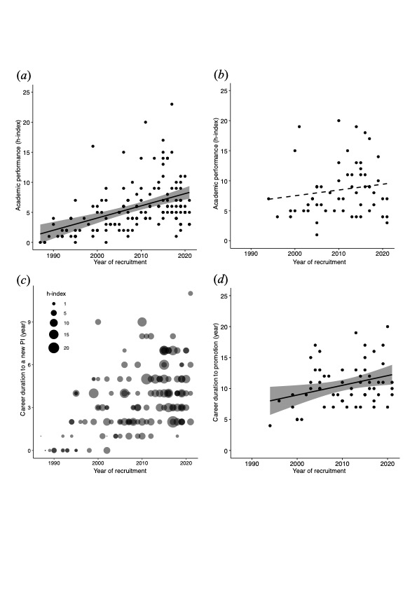

Fig. 1. Temporal variations of academic performance and career duration along with year of recruitment. Academic performance is measured as h-index during the five-year duration prior to (*a*) becoming a new PI and (*b*) promotion to full professor. Career duration is measured as the time elapsed (*c*) between obtaining a PhD degree and starting as a new PI, and (*d*) between starting as a new PI and promotion to full professor. The solid lines present a significant relationship predicted from GLMM, whereas the dashed line presents a non-significant relationship.

The shaded area indicates a 95% confidence interval range. Each point represents an individual PI, with point size in (*c*) adjusted according to the value of h-index.

Furthermore, we investigated whether research output differed before and after getting a job, as well as before and after promotion to full professor. In general, academic performance increased over years (see also Fig. 1a), but the trends differed before and after the years when becoming a PI (Year x before/after: *χ²* = 14.61, d.f. = 1, *p* < 0.001; Fig. 2a). Specifically, those obtaining a faculty position earlier had relatively higher h-index after getting the job, but the difference between before and after becoming a PI decreased and converged more recently. In contrast, research output before and after promotion to full professor did not vary with time (*χ²* = 0.52, d.f. = 1, *p* = 0.470), but depended upon whether the faculty had obtained a PhD from Taiwan (PhD from Taiwan x before/after: *χ²* = 5.00, d.f. = 1, *p* = 0.025; Fig. 2b). Post-hoc analyses showed that PIs who obtained PhD degrees outside Taiwan performed equally well both before and after their promotion (*t* ratio = 0.38, *p* = 0.707), whereas those with PhD degrees from Taiwan showed a significant decrease in performance after the promotion (*t* ratio = -2.47, *p* = 0.017; Fig. 2b), which was also comparatively lower than that of their counterparts with PhD degrees outside Taiwan after the promotion (*t* ratio = 3.19, *p* = 0.002; Fig. 2b).



Fig. 2. Academic performance before and after (**a**) starting as a new PI and (**b**) promotion to full professor. In (**a**) lines present significant relationships predicted from GLMMs, whereas shaded areas indicate 95% confidence interval range. In (**b**) means ± SE are as presented. Each point represents an individual PI.

Discussion:

Summary of the key findings and discussion ideas

1. *Temporal trends in academic performance:*
2. The academic performance of PIs getting a new faculty job increased over the years > Suggests that the academic job market has become increasingly competitive over time and therefore the young researchers should home in on their publications to demonstrate their academic abilities.

1. The academic performance of PIs getting promoted to full professor remained relatively similar over the years > Suggests that after securing the job, the requirements for promotion to full professor might not change that much in the before times and in the recent years (which is reasonable as getting a promotion depends mainly on each PI’s own performance and has nothing to do with competition with other PIs/researchers).
2. The average academic performance of a new male PI was higher than a new female PI, but there was no difference in academic performance between male and female PIs when getting a promotion > The standards for evaluating the suitability of a potential researcher as a new PI might be higher for males than females. But after getting the job, the expectations of academic performance for getting a promotion are similar for both male and female PIs.
3. Whether or not a PI had obtained a PhD degree from Taiwan and the PhD university ranking had no effect on the performance required, either for getting a job or promotion to full professor > The actual hard work during the PhD or post-PhD period may be more important in determining the academic success than the prestige in education itself.
4. *The duration required for becoming a PI or promotion:*
5. PIs spent more time post-PhD before obtaining a tenure-track position in recent years, but higher academic performance reduced this duration > The competition in the academic job market might have intensified in recent years and thus on average it takes longer for a researcher to land a faculty position. However, higher academic performance could help shorten such time, and so the key is to work hard to boost the productivity.
6. PIs spent more time for promotion to full professor when started as new PIs more recently, yet the duration was not affected by their academic performance > The time to becoming a full professor has increased over years, yet surprisingly, higher academic performance does not seem to shorten the time. This could be due to other evaluation criteria for promotion such as teaching and admin services besides publications.

1. Neither the duration to get a job nor the duration required for promotion was affected by whether or not PhDs were obtained from Taiwan, PhD university prestige, and gender > Again the actual hard work during the PhD or post-PhD period may be more important than the prestige in education in determining the academic success. Also, there is no gender privilege in the academia in terms of getting a new falculty job and getting promoted to full professor.
2. *Change in academic performance:*
3. PIs obtaining a faculty position earlier had on average relatively higher h-index after getting the job, but the difference between before and after becoming a PI decreased and converged more recently > The performance of researchers before and after getting a new falculty job have become more similar in recent years.

1. PIs who obtained a PhD outside Taiwan performed equally well both before and after their promotion, whereas those with PhD degrees from Taiwan showed a significant decrease in performance after the promotion, which was also comparatively lower than that of their counterparts with PhD degrees outside Taiwan after the promotion > PIs with foreign PhD degrees might have greater international collaboration opportunities and network conections and thus are able to maintain their relatively high performance compared with PIs with Taiwanese PhD degrees. Additionally, the training in foreign university and the experiences abroad may equipp the PIs with greater academic abilities.
2. Increasing requirement and higher expectation of getting a tenure job and promotion, because of XXX, increasing PhD supply but relatively stable demand for new falculty members. increasing research outputs worldwide, international collaboration, etc; benefits of having high-quality candidates…but few empirical test
3. Rationale for the focus of the field of ecology and evolution; different fields differ in publication rates, employment opportunities, and forms of collaboration; and focus on east Asian, Taiwan, for example.
4. Returnees from foreign more prestigious universities are more advantageous, potentially because they are equipped with new knowledge, techniques, attitudes acquired during international experience. Although a survey of 1447 academics across four continents found no effect of university prestige ([17]), it focuses mainly on western countries. Here, we show that obtaining PhD degrees from foreign universities does provide an edge for the PIs in terms of academic performance, yet overall such an advantage is not a determining factor for academic carrier success.
5. Returnees might have build collaboration network internationally, and so facilitate research publication [18], especially in biological sciences which has evolved to require more international collaboration [19].
6. “Moreover, studies have been conducted to examine the adaptation experiences of overseas returnees and how these experiences may impact on their academic career development (Jiang et al., [2020](https://link.springer.com/article/10.1007/s11233-021-09083-3#ref-CR24); Li et al., [2015](https://link.springer.com/article/10.1007/s11233-021-09083-3#ref-CR28); Li et al., [2019](https://link.springer.com/article/10.1007/s11233-021-09083-3#ref-CR27); Li & Xue [2021](https://link.springer.com/article/10.1007/s11233-021-09083-3#ref-CR29)).”
7. Our findings highlight a pressing need to reassess the recruitment polices of tenure-track positions in academia, and from the perspective of job applicants, what recruiting institutions might be searching for in terms of academic success.

Conclusion:

Acknowledgement:

References:

1. Cyranoski D, Gilbert N, Ledford H, Nayar A, Yahia M. 2011 Education: The PhD factory. *Nature* **472**, 276–279. (doi:10.1038/472276A)

2. Ghaffarzadegan N, Hawley J, Larson R, Xue Y. 2015 A Note on PhD Population Growth in Biomedical Sciences. *Systems Research and Behavioral Science* **32**, 402–405. (doi:10.1002/SRES.2324/EPDF)

3. Xue Y, Larson RC. 2015 STEM crisis or STEM surplus? Yes and yes. *Monthly labor review* **2015**. (doi:10.21916/MLR.2015.14)

4. Schillebeeckx M, Maricque B, Lewis C. 2013 The missing piece to changing the university culture. *Nature Biotechnology 2013 31:10* **31**, 938–941. (doi:10.1038/nbt.2706)

5. Larson RC, Ghaffarzadegan N, Xue Y. 2014 Too many PhD graduates or too few academic job openings: The basic reproductive number R0 in academia. *Systems Research and Behavioral Science* **31**, 745–750. (doi:10.1002/SRES.2210/FULL)

6. In press. Science and Engineering Indicators | NCSES | NSF. See https://www.nsf.gov/statistics/seind/ (accessed on 8 January 2022).

7. In press. What Is The Primordial Reference For The Phrase “Publish Or Perish”? | The Scientist Magazine®. See https://www.the-scientist.com/commentary/what-is-the-primordial-reference-for-the-phrase-publish-or-perish-57976 (accessed on 9 January 2022).

8. Brischoux F, Angelier F. 2015 Academia’s never-ending selection for productivity. *Scientometrics* **103**, 333–336. (doi:10.1007/S11192-015-1534-5)

9. Swihart RK, Sundaram M, Höök TO, Dewoody JA. 2016 Factors affecting scholarly performance by wildlife and fisheries faculty. *The Journal of Wildlife Management* **80**, 563–572. (doi:10.1002/JWMG.1034)

10. Acton SE, Bell AJ, Toseland CP, Twelvetrees A. 2019 A survey of new PIs in the UK. *eLife* **8**. (doi:10.7554/ELIFE.46827)

11. van Dijk D, Manor O, Carey LB. 2014 Publication metrics and success on the academic job market. *Current biology : CB* **24**. (doi:10.1016/J.CUB.2014.04.039)

12. Shin JC, Kehm BM. 2013 Institutionalization of world-class university in global competition. *Institutionalization of World-Class University in Global Competition* , 1–301. (doi:10.1007/978-94-007-4975-7)

13. Chen N. 2021 “Why should a ‘foreigner’ be better than me?”: preferential practices in junior academic faculty recruitment among mainland Chinese universities. *Tertiary Education and Management* , 1–25. (doi:10.1007/S11233-021-09083-3/TABLES/2)

14. R Development Core Team. 2014 R: A language and environment for statistical computing. *R Foundation for Statistical Computing*.

15. Bates D, Maechler M, Bolker B, Walker S. 2015 Fitting linear mixed-effects models using lme4. *R package version*. , 1.0-6.

16. Lenth R v. 2021 emmeans: Estimated marginal means, aka least-squares means. R package version 1.7.1. *R Foundation for Statistical Computing*. **34**, 216–221. (doi:10.1080/00031305.1980.10483031)

17. Laurance WF, Useche DC, Laurance SG, Bradshaw CJA. 2013 Predicting Publication Success for Biologists. *BioScience* **63**, 817–823. (doi:10.1525/BIO.2013.63.10.9)

18. Shen W, Jiang J. 2021 Institutional prestige, academic supervision and research productivity of international PhD students: Evidence from Chinese returnees: *https://doi.org/10.1177/14407833211055225* , 144078332110552. (doi:10.1177/14407833211055225)

19. Kelly S. 2018 The continuing evolution of publishing in the biological sciences. *Biology Open* **7**. (doi:10.1242/BIO.037325/2159)

Supplementary information:



Fig. S1. Global distribution of the universities from which 140 PIs have obtained their PhD degree. Percentage of PhD degrees obtained from USA, Taiwan, and UK are as noted, whereas ‘other’ includes those less than 3%.

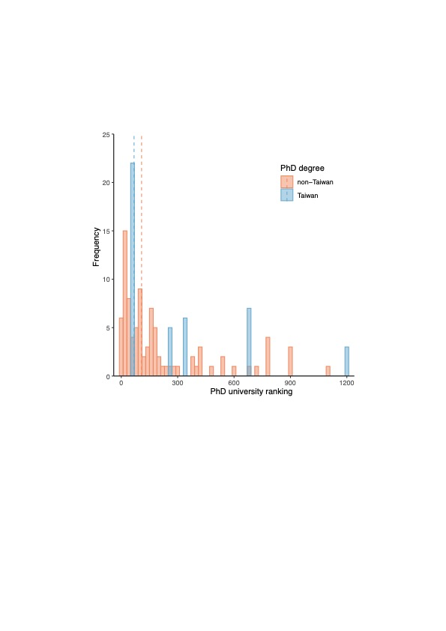

Fig. S2. Frequency distribution of the ranking of universities from which PIs had obtained their PhD degrees inside and outside Taiwan. Dashed lines indicate medians of university ranking for Taiwanese PhD degrees (68) and foreign PhD degrees (108).

|  |  |  |  |  |  |
| --- | --- | --- | --- | --- | --- |
| Table 1. Results of the ANOVAs for academic performance and time required to starting a new PI and promotion to full professor | | | | | |
| **Dependent variable** | **Explanatory variable** | ***χ²*** | **d.f.** | ***p* value** |  |
| Academic performance (new PI) | PhD university location | 1.42 | 1 | 0.234 |  |
|  | PhD university ranking | 0.45 | 1 | 0.503 |  |
|  | Year | 74.68 | 1 | **<0.001** |  |
|  | Gender | 5.73 | 1 | **0.017** |  |
| Academic performance (promotion) | PhD university location | 0.06 | 1 | 0.812 |  |
|  | PhD university ranking | 1.06 | 1 | 0.304 |  |
|  | Year | 0.97 | 1 | 0.324 |  |
|  | Gender | 0.07 | 1 | 0.791 |  |
| Time to new PI | Academic performance | 5.47 | 1 | **0.019** |  |
|  | PhD university location | 1.01 | 1 | 0.315 |  |
|  | PhD university ranking | 1.82 | 1 | 0.178 |  |
|  | Year | 43.08 | 1 | **<0.001** |  |
|  | Gender | 0.78 | 1 | 0.377 |  |
|  | Academic performance x Year | 6.06 | 1 | **0.014** |  |
| Time to promotion | Academic performance | 1.87 | 1 | 0.171 |  |
|  | PhD university location | 1.96 | 1 | 0.161 |  |
|  | PhD university ranking | 0.62 | 1 | 0.430 |  |
|  | Year | 7.03 | 1 | **0.008** |  |
|  | Gender | 3.18 | 1 | 0.075 |  |
| *p* values < 0.05 are highlighted in bold. | |  |  |  |  |

|  |  |  |  |  |
| --- | --- | --- | --- | --- |
| Table 2. Results of the ANOVAs for academic performance before and after starting a new PI and promotion to full professor | | | | |
| **Dependent variable** | **Explanatory variable** | ***χ²*** | **d.f.** | ***p* value** |
| Academic performance (new PI) | PhD university location | 1.20 | 1 | 0.274 |
|  | PhD university ranking | 2.10 | 1 | 0.147 |
|  | Year | 7.01 | 1 | **0.008** |
|  | Gender | 8.48 | 1 | **0.004** |
|  | Before/after | 9.49 | 1 | **0.002** |
|  | Before/after x Year | 14.61 | 1 | **<0.001** |
| Academic performance (promotion) | PhD university location | 10.88 | 1 | **<0.001** |
|  | PhD university ranking | 0.003 | 1 | 0.960 |
|  | Year | 0.52 | 1 | 0.470 |
|  | Gender | 1.68 | 1 | 0.194 |
|  | Before/after | 0.14 | 1 | 0.704 |
|  | PhD university location x Before/after | 5.00 | 1 | **0.025** |
| *p* values < 0.05 are highlighted in bold. | |  |  |  |